Aim: Manage Server Network Security

# Able to configure and manage network security.

# Duration: 3 Hour.

List of Hardware/Software requirements:

1. Computer with 500GB hard disk.
2. 8GB ram
3. Windows server 2019

# Code/Program/Procedure (with comment):

## Step 1:

Open the virtual machine. And go to the Server manage as show below.



## Step 2:

Click on Local server.

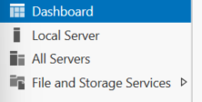

## Step 3:

Scroll down and you can see Roles and features. On right side there have a task option click on and add roles and feature.

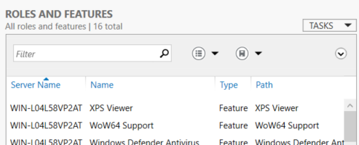

## Step 4:

You can see some option like Before you begin, installation type and server selection simply click on next.

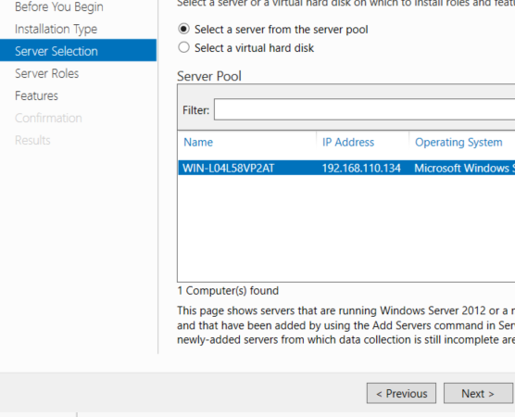

## Step 5:

Know you are on Server role select the DHCP, DNS add this role.

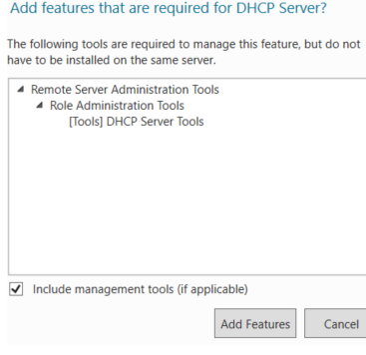

## Step 6:

Know click on next.

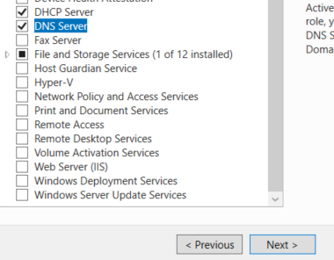

## Step 7:

Know you are on the Features if you want some thing then select and next.

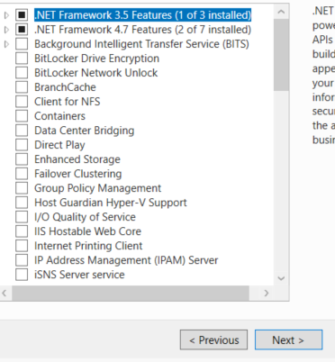

## Step 8:

Know you can see DHCP server and DNS server (this is added by us in step 5) and click on next.

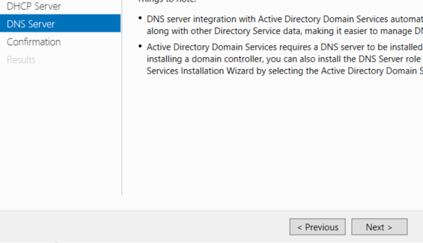

## Step 9:

Here you can see what’s you are add on server and click on install. Wait some time

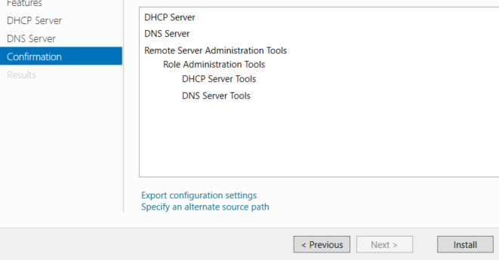

## Step 10:

When installation complete 100% then close the installation program.

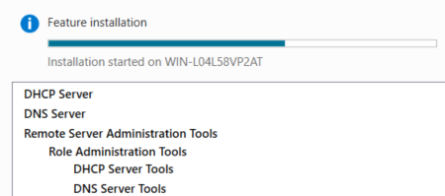

## Step 10:

When installation complete go to the local server and check feature adds or not.

